# **Autonomous Quadcopter Project - Building A Level 4 Autonomous UAV**

**EXECUTIVE SUMMARY**

## **Project Background**

The Unmanned Aerial Vehicle (UAV) sector has become a multi-billion-dollar industry since its inception and has gained a lot of attention by both academia and industry, especially in the last decade. It is by far one of the most flourishing fields in terms of innovation in the 21st century. There has been a sudden explosion of research opportunities in the sector related to autonomous aerial systems. Autonomous UAVs have pushed the existing cutting-edge technologies and algorithms to their limits making room for evolution of the current paradigms in robotics. Corporate companies have started to explore UAVs for various applications like autonomous logistics, surveillance, and even military assessments for example. E-Commerce giants like Amazon have established spin-offs like Prime Air with the objective of achieving rapid last mile delivery using high level autonomy drones. Therefore, this project provides an opportunity for the students and the institute to make a significant contribution to both industry and academia.

In July 2018, the Federation of Indian Chambers in Commerce and Industry (FICCI) organized an [event](http://ficci.in/events-page.asp?evid=23881) “Make in India for Unmanned Aircraft Systems (UAS)” based on which they later released a [report](http://ficci.in/spdocument/23003/Make-in-India-for-UAS.pdf) by the same name. Therein the committee recognized the direct application of autonomous and manual aerial systems in the following sectors: Power and Utility, Agriculture, Highways, Mining, and Railways, among others. All of these are product categories of preference as declared by the [Public Procurement](https://dipp.gov.in/sites/default/files/Product%20List-Public%20Procurement%20Order%202017.pdf) of the Make in India scheme. Furthermore Aerospace and Defence, Railways and construction are among the [27 champion sectors](https://dipp.gov.in/sites/default/files/List_of_Champion_Sectors_08July2020.pdf) recognized by the Department of Promotion of Industry and Internal Trade (DIPP, India). Hence, there is a high probability that this project will receive great support from the concerned government departments if successful, at a later stage.

Such a L4[1] autonomous UAV has large-scale applications as recognized in the report by FICCI and accounts by Economic Times. National Highway Authority of India (NHAI) project consultants use drones for 3D digital mapping of highways. Drones were used on a 250 km stretch of the Nagpur-Mumbai Highway in 2016. This process can be fully automated by a small extension of our proposed UAV system for adapting to outdoor environments. Drones give accurate data which help access the progress of work and comparison with ground reports unlike manual surveys. As a result, the National Railway System used drones for videography inspection of 37,000 km of railway tracks and 3-D mapping of a 3,360 km corridor, a direct application of our project. FICCI’s report projects that at the current rate of increasing adoption of UAS in India, by 2021, the value of industry and market would be around US$ 885.7 million, while global market size will touch US$ 21.47 billion. Hence, innovation in the domain will be highly rewarding and the project is worth investing into.

In this project, we provide an innovative novel approach to make an Autonomous Quadcopter or a UAV. We are splitting this project into 3 subsystems-

1. State Estimation and Localization Subsystem: The State Estimation subsystem will cater to the task of Localization in 3D space by fusing the data from different sensors and use it to generate a position estimate.
2. Visual Perception Subsystem: The Visual Perception subsystem will use advanced Computer Vision algorithms to get intricate details of the environment scenario by mapping the environment (static obstacle), detecting dynamic obstacles and estimating their position and heading.
3. Motion Planning: The Motion Planning subsystem will take the estimated state from the State Estimation subsystem and the obstacle set (static and dynamic) from Visual Perception and will fuse them to generate a trajectory and velocity profile based on set constraints and user inputs for source and destination points.

This project will be the first of its kind in the history of BITS Pilani, Pilani campus. It is our humble expectation as a student tech team that this project will set up a new standard for tech teams and will encourage the upcoming generations of students to explore robotics to a whole new level. This project, owing to its interdisciplinary nature, will attract students from all disciplines to join technical research.

**About the Team**

We are a part of Team Robocon BITS Pilani, which is a registered club under the Student Welfare Division (SWD). Our team has been participating in reputed national and international competitions such as ABU Robocon, IITB-Techfest and several others for the past eight years consistently.

With respect to quadcopters, we have been steady progress for the past 2 years. We have implemented a manually controlled quadcopter as well as a L21 autonomous quadcopter.

Our team is multi-disciplinary and consists of members of multiple batches (first year to fourth year). We are passionate about robotics and coming up with innovative solutions to problems. We are striving to take the standards of Robotics at BITS Pilani to the next level. The links below depict the work that we have already done-

1. UAV Simulation: [Autonomous Navigation](https://drive.google.com/file/d/1jtiKfN4Yyrdu12Q0GMw6rrmJaLMXsyGa/view) ; [MavSDK Simulation](http://bitstimetable.me/Shippo/Simulation.mp4) ; [3D CAD Model](https://pilani21.autodesk360.com/g/shares/SH56a43QTfd62c1cd968765dd2913b813510?viewState=NoIgbgDAdAjCA0IDeAdEAXAngBwKZoC40ARXAZwEsBzAOzXjQEMyzd1C0ATAIwDNvOMXLgC0uAOy4ALCKkBmKdxEBOXr04rlAYykAOYQCYAbEYCsWtAF8QAXSA)
2. L2 Autonomous Quadcopter: [L2 Flight Test](https://drive.google.com/file/d/1-38B67vnrtM2A0TNoSUWoazVHaYemCyd/view?usp=sharing)
3. Manually Controlled Quadcopter: [Link to Photos](https://drive.google.com/drive/folders/17BSe7MhurvuCQcHqnsVBOOl9pCiklYRQ?usp=sharing)

**Deliverables**

This project will result in a Quadcopter capable of:

1. Creating a 3D indoor map of its environment
2. Using the 3D map to develop a mission plan given a Start and an End point as user inputs
3. Navigating as per the mission plan while detecting and avoiding obstacles along its path, even in GPS-denied environments

**Cost Estimate**

|  |  |  |  |  |
| --- | --- | --- | --- | --- |
| Component | Package A Unit | Weight (grams) | Cost^ (INR) | Power Rating (Watts) |
| Frame* | H4 600mm Reptile CF | 626 | 15000 | 0 |
| Motors* | Brother Hobby Tornado T5 Pro 640 KV | 388 | 40000 | 528 |
| Flight Controller | Pixhawk 4 | 16 | 17500 | 2.5 |
| Propellers* | T-Motors CF 1240 | 150 | 25000 | 0 |
| Depth Camera / Stereo Camera* | ZED2 | 124 | 66000 | 1.9 |
| LIDAR/Tracking Camera | Velodyne Puck LITE | 600 | 600000 | 8 |
| IMU | Vectornav - VN 100 | 20 | 72000 | 0.2 |
| On-Board Computer | Nvidia Xavier NX | 467 | 45000 | 7.5 |
| Battery* | 8200mAh (LiPo) | 1200 | 50000 | 0 |
| Tx/Rx, other drone parts (Gimbals, Sensor Protection, Motor Protectors, 3D Printing, ESC) | | 300 | 100000 | 0.5 |
| Ground Bot | TurtleBot 3 - Burger | NA | 60000 | 0 |
| Total |  | 3891 | 10,90,500 | 548.6 Flight Time: 19-22 min |

*\* The quoted cost also includes spares. These spares come in handy in the development & experimentation phase. The prices estimates can be slashed in half for the respective items and the cost per unit can hence be calculated.*

*^ Quoted cost is in INR without import duties and shipping charges (except the LiDAR).*

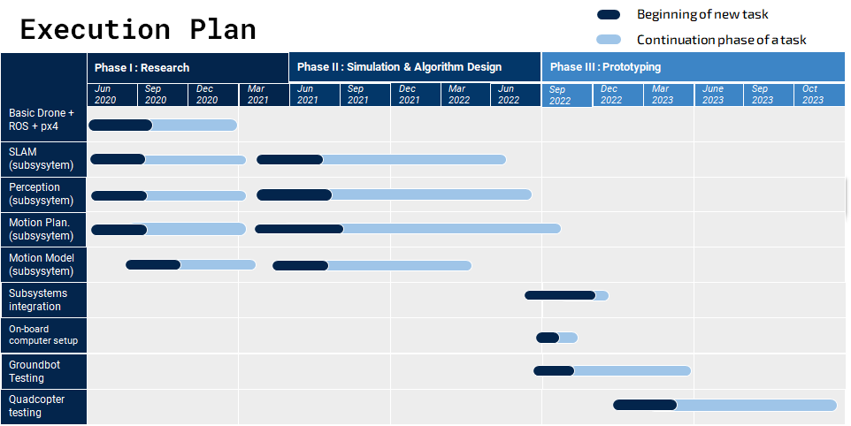

1. The 5 levels of drone autonomy for non-military applications as accepted by drone industries defines the levels as follows:

   Level 0 - No Automation: The drone is 100% manual.; Level 1 - Low Automation: Pilot remains in control. Drone has control of at least one vital function.; Level 2 - Partial Automation: Pilot remains responsible for safe operation. Drone can take over heading, altitude under certain conditions.; Level 3 - Conditional Automation: Pilot acts as fail-back system. Drone can perform all functions given certain conditions.; Level 4 - High Automation: Pilot is out of the loop. Drone has backup systems so that if one fails, the platform will still be operational.; Level 5 - Full Automation: Drones will be able to use AI tools to plan their flights as autonomous learning systems.